**Earthquake prediction model using python**

**Category**  : Machine Learning

**Programming Language:** Python

**Tools** & **Libraries** : Jupyter Notebook, PyCharm, TensorFlow, PyTorch

Scikit-learn, Keras, Pandas, NumPy, Matplotlib, Seaborn, Plotly.spaCy

**Introduction**

In the realm of geophysical science and data-driven insights, this project endeavors to craft a predictive model for earthquake magnitudes. Leveraging a comprehensive Kaggle dataset containing essential earthquake attributes such as time, location, depth, and magnitude, our objective is to harness the power of neural networks to forecast earthquake magnitudes accurately. Through meticulous data exploration, visualization, and model development, we aim to contribute to our understanding of seismic events while enhancing predictive capabilities in this critical field.

**Problem Definition**

The problem is to develop an earthquake prediction model using a Kaggle dataset. The objective is to explore and understand the key features of earthquake data, visualize the data on a world map for a global overview, split the data for training and testing, and build a neural network model to predict earthquake magnitudes based on the given features.

**Design Thinking:**

**Data Source**

* To kickstart the earthquake prediction project, the first crucial step is to identify an appropriate source of data.

**Dataset Link:**[**https://www.kaggle.com/datasets/usgs/earthquake-database**](https://www.kaggle.com/datasets/usgs/earthquake-database)**.**

* This suitable Kaggle dataset contains earthquake data with features like date, time, latitude, longitude, depth, and magnitude.

**Feature Exploration**

**Understanding key features**

* In earthquake prediction, these features typically include attributes like date, time, latitude, longitude, depth, and magnitude. Understanding these features means knowing what they represent and their significance in relation to earthquake prediction.
* "magnitude" is a critical feature as it quantifies the earthquake's size and impact.

**Exploratory Data Analysis (EDA)**

* In earthquake prediction, we use EDA to identify trends, seasonality, or geographic clustering of earthquake occurrences. It can also help identify outliers or anomalies in the data.

**Visualization**

**Data Visualization for Insight**

* It involves creating visual representations of earthquake-related data to gain insights and communicate findings effectively.

**Earthquake Frequency Distribution**

* One crucial visualization you can create is a world map that displays the distribution of earthquake occurrences across different regions. This map can help visualize the frequency and geographic patterns of earthquakes. Using color coding or markers, you can indicate the magnitude of each earthquake event, providing a visual understanding of where stronger earthquakes are more prevalent.

**Temporal Patterns**

* We create time series plots or histograms to visualize temporal patterns in earthquake occurrences. This can reveal trends over time, such as whether earthquake frequency is increasing or decreasing, and if there are any seasonal or cyclical patterns.

**Feature Relationships**

* Creating scatter plots to see if there's a correlation between earthquake depth and magnitude. Heatmaps and correlation matrices can provide a visual representation of feature relationships, helping you identify which features might be most influential for prediction.

**Outlier Detection**

* Visualizations can be used to identify outliers or anomalies in the data. Box plots or violin plots can highlight data points that deviate significantly from the norm, which may require special attention during data preprocessing or model development.

**Data Splitting**

**Training and Testing Sets**

* Training Set: This portion of the data is used to train your machine learning model. The model learns patterns, relationships, and trends from this dataset. It is the foundation upon which your model is built.
* Testing Set (Validation Set): The testing set, sometimes referred to as the validation set, is used to assess the performance of your trained model. It serves as a simulation of real-world data the model hasn't seen during training. The model's predictions on this set are compared to the actual values to evaluate its accuracy and generalization capability.

**Splitting Techniques**

There are various techniques for splitting data:

* Random Splitting: We randomly allocate a percentage of the data (e.g., 70% for training and 30% for testing) to each set. This approach is straightforward but may not consider the data's temporal or spatial distribution.
* Stratified Splitting: In cases where we want to ensure that both training and testing sets have similar distributions of a specific feature (e.g., earthquake magnitude categories), you can use stratified splitting to maintain that balance.
* Time-Based Splitting: If our data has a temporal component, such as earthquake occurrences over time, it's essential to split it chronologically. You can use past data for training and future data for testing to simulate real-world scenarios.

**Cross-Validation**

In addition to a single data split, we employ cross-validation techniques, such as k-fold cross-validation. This involves dividing the data into multiple subsets (folds), repeatedly training and testing the model on different combinations of these folds, and then aggregating the results to obtain a more robust evaluation of your model's performance.

**Methodology**

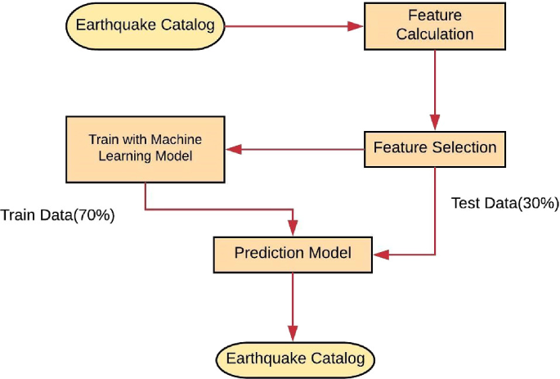

**Model Development**

Magnitude Type, a suitable choice for a regression model is the Random Forest Regressor. Random Forest is a versatile and robust ensemble learning algorithm that can handle both numerical and categorical features, making it a good fit for your dataset with attributes like date, time, latitude, longitude, type, magnitude type, etc.

*Random Forest Regressor :*

**Handling Mixed Data Types**: Random Forest can naturally handle a mix of numerical (e.g., latitude, longitude, depth) and categorical (e.g., type, magnitude type) attributes. It doesn't require extensive data preprocessing to convert categorical data into numerical values.

**Non**-**Linear** **Relationships**: Earthquake magnitude prediction may involve complex, non-linear relationships between the input features. Random Forest can capture such non-linearity efficiently.

**Robustness** **to** **Outliers**: Earthquake data may have outliers due to rare, extreme events. Random Forest is less sensitive to outliers compared to some other regression models like linear regression.

**Feature** **Importance**: Random Forest provides a measure of feature importance, helping you identify which attributes are most influential in predicting earthquake magnitudes. This can offer valuable insights into the underlying patterns.

**Ensemble** **Learning**: Random Forest is an ensemble of multiple decision trees. This ensemble approach reduces overfitting and improves model generalization.

**How it works?**

**Data Collection**: Gathering historical seismic data.

**Data Preprocessing**: Cleaning and preparing the data for analysis.

**Data Labeling**: Defining earthquake occurrence labels (e.g., 1 for earthquake, 0 for no earthquake).

**Model Training**: Using machine learning algorithms to learn patterns in the data that indicate earthquake occurrence.

**Model Evaluation**: Assessing the model's accuracy and performance using testing data.

**Deployment (Optional):** Implementing the model for real-time or batch classification of seismic events.

**Continuous Monitoring**: Updating and retraining the model as new data becomes available.

**Conclusion:**

In conclusion, developing a machine learning model for earthquake prediction involves the analysis of historical seismic data to classify seismic events based on past patterns. While this approach can provide valuable insights and assist in earthquake monitoring, it does not enable the precise prediction of specific earthquakes in advance. Earthquake prediction remains a challenging scientific endeavor, and accurate, long-term earthquake forecasting is not currently achievable with existing technology and knowledge. Collaborating with experts in seismology and continuously improving machine learning models can contribute to our understanding of seismic events and enhance earthquake early warning systems for improved public safety.